|  |
| --- |
| Android software stack |
| **Deepika** |
| Android Mascot, android logo, HD wallpaper |

2/22/2021

**Android Architecture**

Android operating system is a stack of software components which is roughly divided into five sections.**android architecture** or **Android software stack** is categorized into five parts:

**Overview :**

* **Five Layers**

▫ Linux Kernel

▫ Adroid Runtime

▫ Libraries

▫ Application Framework

▫ Applications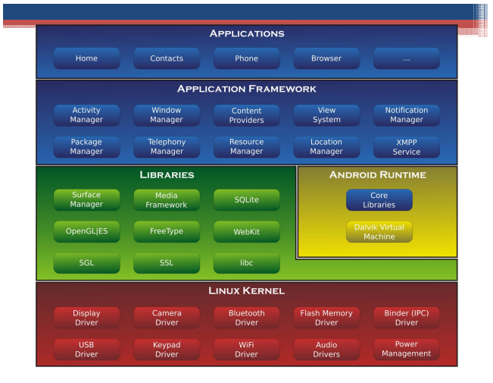

**i. Linux Kernel**

Linux kernel is the bottom-most and important layer of the Android architecture and it is the core part of Android architecture.

It provides features such as:

* **Security**
* **Process management**
* **Memory management**
* **Device management**
* **Multitasking**

It is also responsible for a level of abstraction between device hardware and upper layers of Android architecture. It consists of device drivers like camera, flash memory, Display, keypad, Wifi etc.

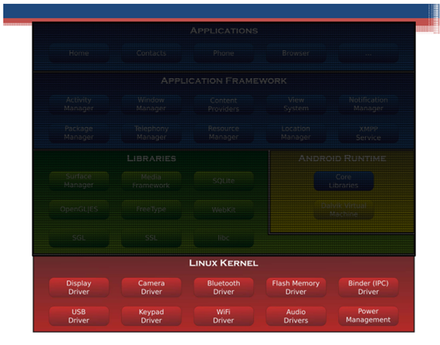

Hardware Abstraction Layer (HAL)

* Software hooks between stack and hardware
* Hardware Specific

HAL defines a standard interface for hardware vendors to implement, which enables Android to be agnostic about lower-level driver implementations. Using a HAL allows you to implement functionality without affecting or modifying the higher level system. HAL implementations are packaged into modules and loaded by the Android system at the appropriate time.

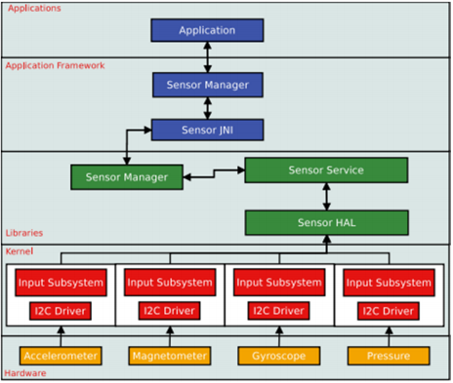

This layer consists of a set of Libraries and Android Runtime. The Android component is built using **native codes** and require **native libraries**, which are written in C/C++ and most of the libraries are open source libraries. Also, this layer handles data that is specific to the hardware. Some of the native libraries are SSL, SQLite, Libc, OpenGL, media framework, FreeType and Surface Manager.

ii. Libraries

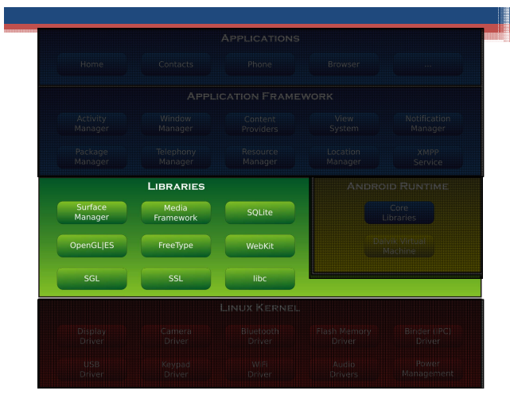

Library Examples :

• WebKit

Web Browser Engine

• OpenGL

High Performance Graphics

Render 2D or 3D Graphic Content

• libc

Generic C library

• SQLite

Storage and sharing of application data

It comprises of DVM (Dalvik Virtual Machine). Just like[**JAVA uses JVM**](https://data-flair.training/blogs/java-virtual-machine-jvm/), Android uses DVM to optimize battery life, memory and performance. The byte code generated by the**Java compiler** has to be converted to .dex file by DVM, as it has its own byte code. Also, multiple class files are created as one .dex file and the compressed .jar file is greater than the uncompressed .dex file.

iii. Android Runtime

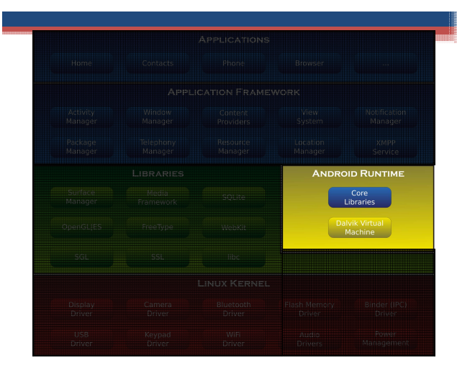

The application framework built on top of the native library layer provides us with Application programming interface and higher-level services. Also, the features of the Android operating system are available to us through API’s written in form of [**JAVA classes**](https://data-flair.training/blogs/java-class-and-object/).  And, Android developers use these high-level services to build applications.

iv. Application Framework

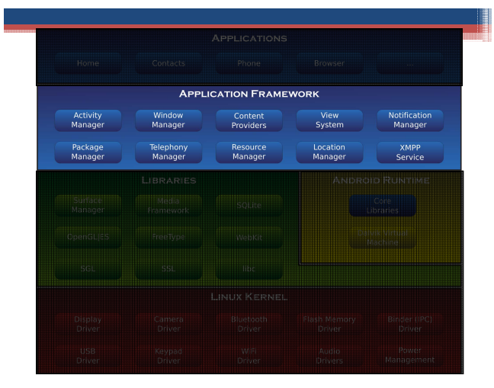

v. Applications

It is the top-most layer of Android architecture. This layer consists of native Android applications and third-party installed apps. They are bundled in an Android package and all the applications that are to be installed are written in this layer only such as contacts, games, settings, and messages.

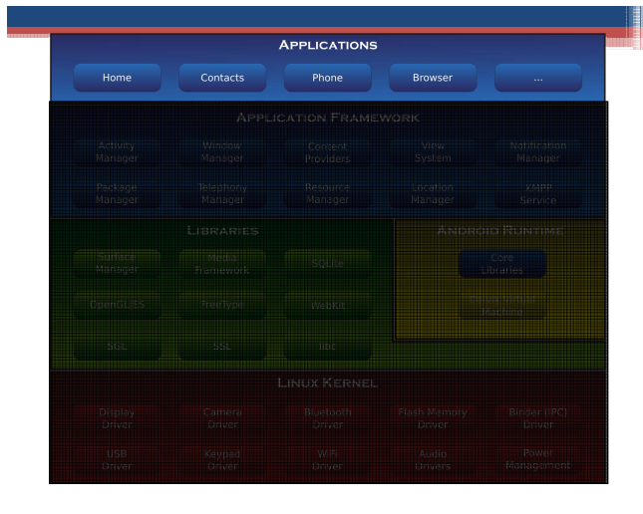

Call Flow

